

- Student name: omar abuhassan
- Student ID:22110264
- Student Section number:1
- Course Toutr: Ahmed Bataineh

Part 1 and Part 2
Q1)
Explain whether each of the scenarios below is a classification or regression problem. Indicate whether the main goal is inference or prediction and specify n (number of observations) and p (number of features).
- Heart Disease Dataset
- Type of Problem: Classification (binary outcome: developed heart disease = Yes/No).
- Goal: Inference – the aim is to identify which factors (age, weight, blood pressure, cholesterol) are most strongly associated with heart disease.
- n (observations): 1,000 patients.
- p (features): 4 (age, weight, blood pressure, cholesterol).

- price of a new house
- Type of Problem: Regression (continuous outcome: house price).
- Goal: Prediction – the company wants to estimate the price of a new house.
- n (observations): 5,000 houses.
- p (features): 4 (square footage, number of bedrooms, age of property, location rating).
- App Usage Dataset
- Type of Problem: Regression (continuous outcomes: number of users and total time spent).
- Goal: Prediction – the startup aims to forecast future values for the upcoming month.
- n (observations): ≈ 1,825 (daily data points over 5 years).
- p (features): 3 (daily active users, peak usage hours, most in-demand features).

Q2)
You are part of a research team designing an AI-powered medical diagnosis assistant. The system should handle the following tasks:
- Detect tumors in MRI scans.
- Classify skin lesions into benign or malignant categories.
- Group patients with similar genetic profiles for personalized treatment suggestions.
- Predict the likelihood of a patient being readmitted to the hospital within 30 days.
- Detect faulty readings from wearable medical devices.
For each task:
- Identify whether it is supervised or unsupervised learning.
- Suggest a suitable ML algorithm and justify the choice. Include training and prediction time complexities.
- Explain why machine learning is essential for this medical system.
1) Detect tumors in MRI scans
- Learning: Supervised.(binary: tumor vs. no tumor).
- Algorithm. : SVM on .engineered radiomic. features (intensity./texture./shape).
- Why this choice: SVM handles .nonlinear boundaries .well and works .strongly on high-dimensional .tabular features extracted from images.
- Complexity ≈ $O\left(N^{2}d\right)to O(N^{3})$.

2) Classify skin lesions (benign vs. malignant)
- Learning: Supervised. (binary. classification).
- Algorithm. : Logistic. Regression .(with .regularization).
- Why this choice: Gives calibrated probabilities and clear interpretability for clinical settings; strong baseline on tabular/image-feature embeddings.
- Complexity ≈ $O(END)$ (E = epochs)

3)Group patients with similar genetic profiles (personalized treatment)
- Learning: Unsupervised (clustering).
- Algorithm : Random Forest to learn subtype rules once labels exist.
- Why this choice: Robust on high-dimensional, noisy genomic features; handles nonlinear interactions; offers feature importance for biomarkers.
- Complexity: ≈ $O(TN d\log{N})$ (T=trees)

4) Predict 30-day readmission
- Learning: Supervised (binary classification).
- Algorithm : Gradient Boosting (Boosted Trees).
- Why this choice: Captures nonlinearities and feature interactions common in EHR data; usually outperforms linear baselines while handling mixed feature types.
- Complexity: ≈ $O(TN d \log{N})$ (T=trees, histogram splits)

5) Detect faulty readings from wearables
- Learning: Unsupervised anomaly detection (fault labels are rare).
- Algorithm (from slides, supervised case): Decision Tree (or Random Forest if you allow ensembles).
- Why this choice: Fast, interpretable rules for operational monitoring; handles mixed signals and missingness.
- Complexity ≈$O(N d\log{N})$

Why machine learning is important in medical systems
- Nonlinear complex patterns: medical images, genomics and electronic health records have relationships that static bases cannot access; machine learning learns them from data.
- Generalization and calibration: models provide probabilistic risk scores and can be validated by mutual verification/withholding of certification according to your 'model evaluation' slides.
- Possibility of interpretation when needed: logistic/tree/random forests provide coefficients or significance of the feature to support a doctor's review.
- Scalability: automation of the screening/sorting process and continuous monitoring with consistent performance

Q3)
Given a dataset with the following points, determine the weights w and bias b for the decision boundary of a linear SVM, and explain the process in detail.
X1 | X2 | Label
7 | 6 | -1
8 | 5 | -1
10 | 7 | 1
11 | 8 | 1

- decision function
$$f(x)=w.x+b$$
- If
$$f\left(x\right)=\left\{\begin{aligned}>0, &=1 \\ <0, &=-1\end{aligned}\right.$$
- For classes
- Training objective: find (w/b) that maximize the margin
$$y_{i}\left(w.x+b\right)≥1 ∀_{i}$$
$$\left\{\begin{aligned}10w.7w+b=1 \\ 11w.8w+b=1 \\ 7w.6w+b=-1 \\ 8w.5w+b=-1\end{aligned}\right.$$
- Subtract 2 eq
$$\left[w\left(10,7\right)+b\right]-\left[w\left(8,5\right)+b\right]=1-\left(-1\right)$$
$$w.\left(2,2\right)=2 2w_{1}+2w_{2}=2 w_{1}+w_{2}=1$$

- Subtract the second 2 eq
$$\left[w\left(7,6\right)+b\right]-\left[w\left(8,5\right)+b\right]=(-1)-(-1)$$
$$w_{1}=w_{2}$$
- From the 2 eq
$$w_{1}=w_{2}=0.5$$
- Use any eq to solve b
$$w\left(8,5\right)+b=-1$$
$$0.5 . 8+0.5 . 5+b=-1$$
$$b=-7.5$$
- Final parameters:$w=\left(0.5,0.5\right) , b=-7.5$
- decision fun:$f\left(x\right)=0.5\left(x_{1}+x_{2}\right)-7.5$
- boundary:$f\left(x\right)=0 x_{1}+x_{2}=15$
checking the point
(7,6): $0.5\left(13\right)-7.5=-1$
(8,5):$0.5\left(13\right)-7.5=-1$
(10,7):$0.5\left(17\right)-7.5=1$
(11,8):$0.5\left(19\right)-7.5=2$correct classified 1
Q4)
Why does applying the sigmoid function in logistic regression allow the model to perform classification? Give an example. Can you still use the sigmoid function for multiclass classification? Explain the reasoning.
The logistic regression is one of the best main options used in classification tasks and is characterized in cases of binary linear results, the basis of this algorithm is the Predictor:
$$z=w^{⊺}x+b$$
The main problem is that this linear model can take any value that falls between ($∞,-∞$) these values cannot be interpreted as probabilities because the probabilities must lie between 0 and 1, and to solve this problem the function was created sigmoid function Or, as some people call it, the logistic function :
$$σ\left(z\right)=\frac{1}{1+e^{-z}}$$
What makes it ideal for classification
- Finite values: where makes all values of z appear between 0 and 1 which makes them values interpretable as probability

- Monotonicity: as the z values increase, the values of the function also increase, and this leads to ensuring that the linear values rise, and this is what makes them correspond to a higher probability of falling into the positive category
- Facilitate decision-making: the function provides values between 0 and 1, which avoids an unjustified increase in values and makes the decision-making process easier and based on gradient-based optimization

Therefore, the probability is
$$P\left(Y=1\right)\left|X=x\right)=σ=(w^{τ}x+b)$$
Accordingly, the decision -making process takes place as follows if the model is raised with a higher value and is usually 0.5, then the result is positive(1), but if it is less than it, the result is negative(0).
Ex:
In one of the exams, a model of predicting a student mark was designed according to the study hours, where the value of 1 is given for success and 0 for failure.
The LR model will give as follows:
$$z=-4+0.1∙x(hours)$$
If student study 30 h:
$$z= - +0.1\left(30\right)=-1$$
Sigmoid for 30 h:
$$e^{-z}=e^{-(-1)}≈2.7$$
$$σ\left(-1\right)=\frac{1}{1+e}≈0.269(26.9\%)$$
In these case $σ(z)<0.5$ so predict fail

If student study 70 h:
$$z= - +0.1\left(70\right)=3$$
Sigmoid for 70 h:
$$e^{-z}=e^{-3}≈0.0498$$

$$σ\left(-1\right)=\frac{1}{1+0.0498}≈0.9526(95.26\%)$$
In these case $σ(z)>0.5$ so predict pass

Can the Sigmoid Function Be Used for Multiclass Classification?
Categories. This constraint arises because the sigmoid produces only one probability value, which works when there are only two categories. For multi-class problems, we need a probability distribution across multiple categories, where all probabilities are non-negative and add up to 1.
There are two main approaches to addressing this problem:

One versus Rest (OvR) with Sigmoid:
- The separate logistic regression model is trained for each class, treating that class as the positive category and all other classes as negative.
- Each model uses a sigmoid curve to output the probability score.
- At the time of the prediction, the class with the highest probability score is chosen.
- Limits: The sum of the probabilities across categories is not naturally equal to 1, which can complicate the interpretation process
SoftMax Function (Preferred):
The SoftMax function generalizes the sigmoid to handle multiple classes simultaneously.
For K classes, the probability that Y=k
is:
$$P\left(Y=k | X=x\right)=\frac{e^{zx}}{\sum_{j=1}^{K}{e^{zj}}}$$
Where $zk=w_{k}⊺x+b_{k}$
SoftMax ensures that all odds are between 0 and 1 and that their sum is exactly equal to 1, making it the standard approach to multi-category logistic regression.
Conclusion
For multi-class problems, it is still possible to use the sigmoid in one frame against the rest, but the most initial solution is to use the SoftMax function, which generalizes the sigmoid to multiple classes by producing uniform probabilities across all possible outcomes

Q5)
Using the dataset below, compute entropy and information gain for each feature. Draw the decision tree learned from this data without pruning.
BMI | Blood pressure | Family History (Heart Disease) | Stroke
N | N | N | N
L | H | Y | N
L | H | Y | N
H | H | N | Y
H | N | Nno | Y
N | N | Y | N
H | N | Y | Y
L | H | N | Y
L | H | N | Y
N | N | N | N

- Target entropy
We have 10 record 5 of them shows yes and another 5 shows no
That mean the probability of y is 0.5 and probability of n is 0.5
$$H\left(S\right)=-0.5\log_{2}\left(0.5\right){-}0.5\log_{2}(0.5){=}1$$
- Information Gain per feature
- BMI$∈${L, N, H}
BMI=L: (Y=2, N=2) H=1
BMI=N: (Y=0, N=3) H=0
BMI=H: (Y=3, N=0) H=0
Weighted entropy:
$$\frac{3}{10}∙0+\frac{4}{10}∙1+\frac{3}{10}∙0=0.4$$
IG(BMI)=1-0.4=0.6
- Blood Pressure$∈${N, H}
BP=N: (Y=2, N=3)H$≈$0.971
BP=H: (Y=3, N=2)H$≈$0.971
Weighted entropy:
$$2*\left(\frac{5}{10}∙0.971\right)=0.971$$
IG(BP)=1-0.971=0.029
- Family History$∈${Y, N}
FH=Y: (Y=1, N=3)H$≈$0.811
FH=N: (Y=4, N=2)H$≈$0.918
Weighted entropy:
$$\frac{4}{10}∙0.811+\frac{6}{10}∙0.918=0.875$$
IG(FH)=1-0.875=0.125
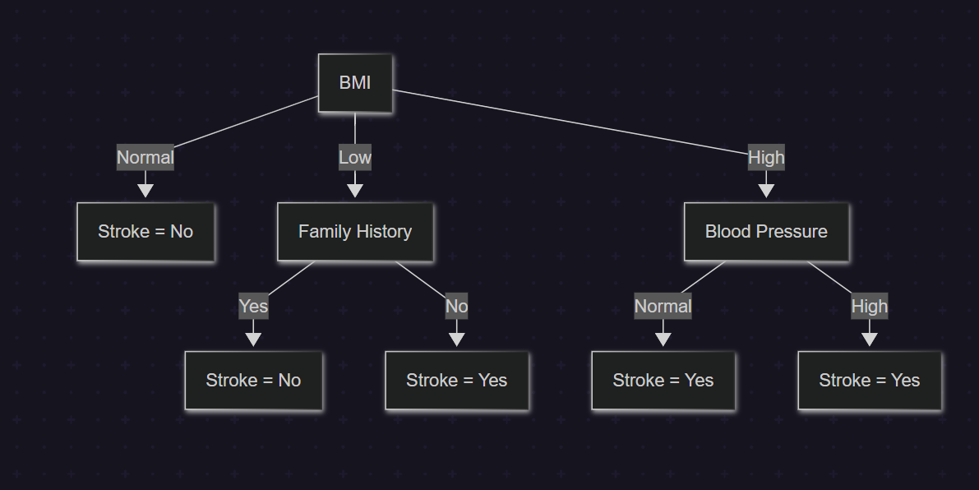
Q6)
A logistic regression model is fitted for student exam success:
X1​ = hours studied, X2 = number of practice exams taken, Y = pass (1) or fail (0).
Estimated coefficients: B0=−4, B1=0.04, B2=0.6
- Estimate the probability of passing for a student who studies 50 hours and takes 4 practice exams.
- Find the minimum number of practice exams needed for a student who studies 30 hours to have at least a 70% chance of passing.
Logistic Regression Model:
$$logit\left(p\right)=B_{0}+B_{1}X_{1}+B_{2}X_{2}$$
$$P=\frac{1}{1+e^{-(logit(p))}}$$
Where :
$B_{0}$=-4
$B_{1}$=0.04 (co of hours)
$B_{2}$=0.6 (co of exam)
$X_{1}$=hours
$X_{2}$=exam
1.Estimate the probability of passing
P= probability of pass
If $X_{1}=50$ and $X_{2}=4$
$$logit\left(p\right)=-4+0.04∙50+0.6∙4=0.4$$
$$p=\frac{1}{1+e^{-0.4}}≈\frac{1}{1+0.67}≈0.5987$$
If the student studies for 50 hours and trains 4 exams, then his success probability is60%

2.Find minimum number of practice exams
$X_{1}$=30 and p=0.7
$$p=\frac{1}{1+e^{-z}} z=\ln{(\frac{p}{1-p})}$$
$$\ln\left(\frac{0.7}{0.3}\right)≈\ln\left(2.3333\right)≈0.847$$

Then by using the eq
$$z=-4+0.04∙30+0.6X_{2}=0847$$
$-2.8+0.6X_{2}=0.8470.6X_{2}=3.647$
$X_{2}=\frac{3.647}{0.6}$=6.0783
This means that the minimum number of exams that a student can study in order to study is 7 exams
Q7):
Consider a simple regression problem with the following data:
Instance | True Value
1 | 10
2 | 15
3 | 20

You are using gradient boosting with the following setup:
- Initial Prediction: f₀(x)=12 for all instances.
- Learning Rate: η=0.1.
Tasks:
- Calculate the initial residuals after f₀(x).
- Update predictions after the first weak learner.
- Compute the residuals for the second iteration.
- Update predictions after the second weak learner.
- Explain how the algorithm improves the prediction after each iteration?
$f_{0}\left(x\right)=12$
Lr=0.1
- Calculate the initial residuals after f₀(x).
Residual ($r_{1})$ = True - $f_{0}\left(x\right)$
Record | True value | $$f_{0}\left(x\right)$$ | $$r_{1}$$
1 | 10 | 12 | -2
2 | 15 | 12 | 3
3 | 20 | 12 | 8

- Update predictions after the first weak learner.
$$f_{1}\left(x\right)=f_{0}\left(x\right)+lr∙r_{1}$$
Record | f₀(x) | r₁ | $f_{1}(x)$
1 | 12 | -2 | 12 + 0.1×(-2) = 11.8
2 | 12 | +3 | 12 + 0.1×(3) = 12.3
3 | 12 | +8 | 12 + 0.1×(8) = 12.8

- the residuals for the second iteration.
Residual ($r_{2})$ = True - $f_{1}\left(x\right)$
Record | True Value | f₁(x) | r₂
1 | 10 | 11.8 | -1.8
2 | 15 | 12.3 | 2.7
3 | 20 | 12.8 | 7.2

- Update predictions after the second weak learner.
$$f_{2}\left(x\right)=f_{1}\left(x\right)+lr∙r_{2}$$
Record | f₁(x) | r₂ | f₂(x)
1 | 11.8 | -1.8 | 11.8 + 0.1×(-1.8) = 11.62
2 | 12.3 | +2.7 | 12.3 + 0.1×(2.7) = 12.57
3 | 12.8 | +7.2 | 12.8 + 0.1×(7.2) = 13.52

- Explain how the algorithm improves the prediction after each iteration?
- Every iteration process adds a small correction in the direction of reducing error
- After each step, the error ratio becomes lower
- After a certain number of iterations, the model becomes more accurate
- Through the learning rate, the gradual development in the algorithm is guaranteed instead of excessive
Q8)
Below is a description of three machine learning (ML) applications integrated with your Gmail account to filter and delete spam emails. For each application, compute the True Positive Rate (TPR) and False Positive Rate (FPR). Then, describe how the corresponding point would appear on the ROC curve and explain under what circumstances ROC analysis provides more insight than a confusion matrix.
Application A: After testing with 50 emails—25 of which were actually spam and 25 non-spam—the results were as follows: The recall was 76%, and the F1-score was approximately 82.4%.
Application B: After testing with 50 emails—25 of which were actual spam and 25 non-spam—the results were as follows: The recall was 88%, and the precision was 84%.
Application C: After passing the following test emails, the results were as below. S denotes a spam email, while N refers to a non-spam (important) email.
Actual | S | S | S | S | S | S | S | S | S | S | S | S | S | S | S | S | S | S | S | S | S | S | S | S | S
Predicted | S | S | S | S | S | S | S | S | N | S | S | N | S | S | S | S | S | S | S | S | S | S | S | S | S

Actual | N | N | N | N | N | N | N | N | N | N | N | N | N | N | N | N | N | N | N | N | N | N | N | N | N
Predicted | S | S | N | S | N | N | N | S | N | N | N | N | S | N | N | S | N | N | N | N | N | N | N | N | N

A:
- Recall = $\frac{TP}{TP+TN}$=0.76 TP = 0.76 * 25 = 19 FN = 25-19=6
- $F_{1}=\frac{2*Precision *Recall}{Precision+Recall}=0.824=\frac{2*Precision*0.76}{Precision+0.76}=Precision ≈0.9$
- Precision = $\frac{TP}{TP+FP}=0.9 FP=\frac{TP}{0.9}-TP= \frac{19}{0.9}-19=2.11 ≈2 TN=25-2 ≈23$
Metrics
- TP = 19, FN = 6, FP = 2, TN = 23
- Recall (TPR)= $\frac{19}{19+6}=0.76$
- Fale Positive Rate (FPR) = $\frac{2}{2+23}=0.08$

B:
- Recall (TPR) =$\frac{TP}{TP+TN}=0.88 TP=0.88*25=22 FN=25-22=3$
- Precision = $\frac{TP}{TP+FP}=0.84 FP=\frac{22}{0.84}-22=4.19 ≈4 TN=25-4 ≈21$
Metrics
- TP = 22, FN = 3, FP = 4, TN = 21
- Recall (TPR) = $\frac{22}{22+3}=0.88$
- Fale Positive Rate (FPR) = $\frac{4}{4+21}=0.16$

c:
- TP: Count of predicted S when actual = S = 23
- FN: Predicted N but actual = S =
- FP: Predicted S but actual = N = 4
- TN: Predicted N and actual = N = 21
Metrics
- Recall (TPR) = $\frac{23}{22+2}=0.92$
- Fale Positive Rate (FPR) = $\frac{4}{4+21}=0.16$
App | TP | FN | FP | TN | Recall (TPR) | FPR
A | 19 | 6 | 2 | 23 | 0.76 | 0.08
B | 22 | 3 | 4 | 21 | 0.88 | 0.16
C | 23 | 2 | 4 | 21 | 0.92 | 0.16

ROC Curve Points
- App A (0.08, 0.76): strong balance; fewer false positives, moderate detection.
- App B (0.16, 0.88): higher detection than A, tolerates more FP.
- App C (0.16, 0.92): best TPR here, at the same FPR as B (more aggressive detector).
When is ROC more insightful than a confusion matrix?
Across thresholds vs one threshold: A confusion matrix .summarizes just one cut-off; the ROC summarizes performance over all thresholds, showing the .trade-off between TPR (sensitivity) and FPR . This makes ROC ideal when you want to choose a threshold later or compare models independently of a single cut-off.
Imbalanced classes cost-sensitive .settings: Accuracy or a single confusion matrix can be misleading when. positives are rare or when FP vs FN costs differ; ROC reveals how detection improves. as you accept more FPs, letting you pick the operating point that matches real-world costs
Comparing classifiers. with AUC: ROC enables AUC, a. single scalar summarizing average performance over thresholds (higher is better). Useful for fair comparisons. (Ideal ROC hugs the top-left corner; chance is the diagonal with AUC ≈ 0.5.)
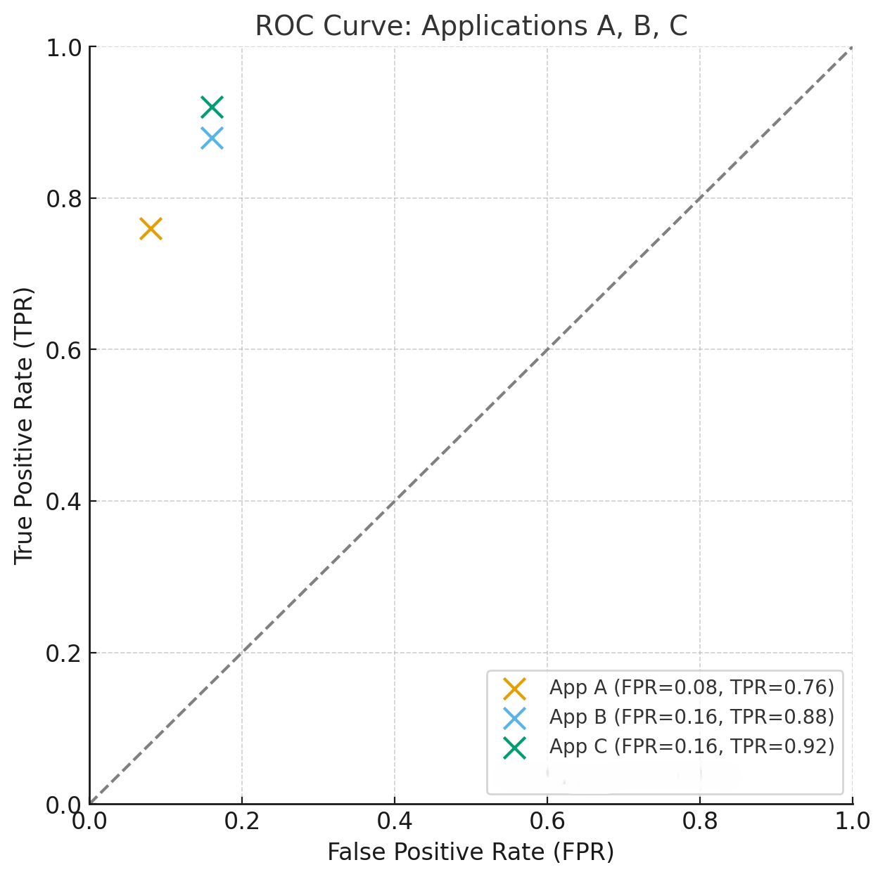

Q9)
What are the key signs of underfitting and overfitting during the model evaluation process? What are the primary causes of overfitting, and how can it be mitigated? Provide at least three techniques
One of the basics of the form evaluation process is to assess the extent of its ability to generalize the data that was not seen (test data) and one of the problems facing the deficiency models in underfitting and overfitting and these problems are closely related to balance
- underfitting
This problem occurs if the data contains complexity or is above the level of the model so that the model cannot understand the patterns in the training data and therefore its results are very poor in the training and test data
A common sign of a underfitting
- Poor results in the training data
- Poor results in the test data
- Inability to improve the results with more training
The reason for this problem is that the model It is based on assumptions about the data, which makes the problem to be solved excessively simple
- Overfitting
This problem occurs when the form is mastered irrationally, as perfection includes all abnormal values ​​and confusion, and this leads to a high evaluation in training data while declining in testing data the common signs of overfitting:
- a high evaluation in training data
- low evaluation in the test data
the main cause of this problem is due to the high contrast where the model is flexible Very with a high sensitivity to training data, which leads to a weak circular
Bias and variance swap
Bias refers to the error caused by incorrect assumptions in a learning algorithm (e.g., using a linear model of nonlinear data).
Variation indicates the model's sensitivity to small changes in the training dataset.
According to the Bias and Variance Swap Slide:
- underfitting = High Bias, Low Variance.
- overfitting = Low bias, high variance.
The goal is to find a balance where bias and variation are minimized for optimal performance
- Techniques to Mitigate Overfitting
- Regularization
This method works by adding a penalty term to the loss function to reduce complexity by reducing the coefficients associated with unimportant features
This method is divided into two methods
- Lasso
adds the following equation$λ\sum{w_{j}^{2}}$
reduces the coefficients to zero
removes features that are not strongly related to the target

- Ridge
adds the following equation$λ\sum{\left|w_{j}\right|}$
Approximates the coefficients to zero
does not remove any feature.
- Benefit
preventing the model from saving noise in training data
Complexity control
Lasso also gives a sparser, simpler model.

- Cross-Validation
Cross-validation is a resampling technique used to evaluate the performance of model generalization by dividing the data into multiple training and testing groups.
It gives a more accurate estimate of how the model performs on invisible data, preventing the model from being overly tuned to split a particular training test.
Cross-validation through k-Fold:
Divide the data into k folds. Train on k–1, test on 1, and repeat the process for each fold. Calculate the average of the results.

- Benefits:
Helps detect problems related to variation.
Improved model selection robustness.
3. Early Stopping
a technique in which training is stopped before the model begins to over-fit the training data. In incremental boost, more iterations can improve performance, but after a certain point, they start to make noise. Early stop monitors for a verification error and stops when it increases.
- Benefits:
Prevents overtraining.
maintains a good balance between bias and contrast.
Saves calculation time.
Q10)
The table below presents the wholesale prices of commercial goods (in thousand JOD), based on the total quantity of items sold. Use an appropriate machine learning approach (either regression or classification) to complete Table 2, which contains the total sales of items. Your task is to predict the required wholesale price (in thousands of JOD) for each item. Use a suitable evaluation metric to assess the accuracy of your predicted results and the performance of the machine learning model.
Table 1: Training Data Set
quantity of items sold | wholesale prices
5 | 26
8 | 38
6 | 30
11 | 50
7 | 34
12 | 54
4 | 22
9 | 42
13 | 58
3 | 18
14 | 62

Table 2: Testing Data Set
quantity of items sold | Predicted | Actual
25 |  | 108
83 |  | 335
94 |  | 370

The LR equation:
$$y=wx+b$$
W(slop) equation:
$$w=\frac{\sum{(x_{i}-\overline{x})(y_{i}-\overline{y})}}{\sum{{(x_{i}-\overline{x})}^{2}}}$$
B(intercept):
$$b=\overline{y}-w\overline{x}$$

$$\overline{x}=\frac{5+8+6+11+7+12+4+9+13+3+14}{11}≈9.27$$
$$\overline{y}=\frac{26+38+30+50+34+54+22+42+58+18+62}{11}≈39.45$$

x | y | $$x_{i}-\overline{x}$$ | $$y_{i}-\overline{y}$$ | $$(x_{i}-\overline{x})(y_{i}-\overline{y})$$ | $${(x_{i}-\overline{x})}^{2}$$
5 | 26 | -3.36 | -13.45 | 45.192 | 11.290
8 | 38 | -0.36 | -1.45 | 0.522 | 0.130
6 | 30 | -2.36 | -9.45 | 22.302 | 5.570
11 | 50 | 2.64 | 10.55 | 27.852 | 6.970
7 | 34 | -1.36 | -5.45 | 7.402 | 1.850
12 | 54 | 3.64 | 14.55 | 53.002 | 13.250
4 | 22 | -4.36 | -17.45 | 76.042 | 19.010
9 | 42 | 0.64 | 2.55 | 1.632 | 0.410
13 | 58 | 4.64 | 18.55 | 86.072 | 21.530
3 | 18 | -5.36 | -21.45 | 114.972 | 28.740
14 | 62 | 5.64 | 22.55 | 127.302 | 31.820

$$w=\frac{562.29}{140.57}≈4$$
$$b=39.45-\left(4*8.36\right)=5.83$$
Based on the above equation:
$$y=4x+5.83$$

Quantity (x) | Prediction | Actual (y)
25 | $$4*25+5.83=105.83$$ | 108
83 | $$4*83+5.83=337.83$$ | 335
94 | $$4*94+5.83=381.83$$ | 370

Evaluation
$$MAE=\frac{\left|108-105.83\right|+\left|335-337.83\right|+\left|370-381.83\right|}{3}=5.61$$
$$RMSE=\sqrt{\frac{{(108-105.83)}^{2}+{(335-337.83)}^{2}+{\left(370-381.83\right)}^{2}}{3}}≈7.13$$
$$SST={(108-271)}^{2}+{(335-271)}^{2}+{(370-271)}^{2}=26449+4096+9801=40346$$
$$SSE={(108-100.75)}^{2}+{(335-326.67)}^{2}+{(370-365.56)}^{2} =52.56+69.39+19.64=141.59$$
$$R^{2}=1-\frac{SSE}{SST}=1-\frac{141.59}{40346}=0.9965$$
Q11)
You are given the following observed and predicted values for a regression model:
Observed | Predicted
2 | 1.8
3 | 3.1
5 | 4.9
7 | 6.8
8 | 8.0

Tasks:
- Calculate the mean of observed values.
- Compute SST, SSE, and R^2.
- Interpret R^2 in context.
$$\overline{y}=\frac{2+3+5+7+8}{5}=5$$
$$SST=\sum{{(y_{i}-\overline{y})}^{2}}=26$$
$$SSE=\sum{{(y_{i}-\acute{y})}^{2}}=0.1$$
$$R^{2}=1-\frac{0.1}{26}=0.9962$$
Interpretation of $R^{2}$
These variable measures how similar the curve of the predicted data is to the curve of the original data and usually falls between the values 0 and 1
The closer to 1, the predicted results are closer to reality, and the closer to 0, the results are bad and far from reality
Calculations have shown that${ R}^{2}$=99.62%, which means that the model shows a strong interpretation of the data and creates a curve very close to the original curve
Q12)
Fit two polynomial regression models for the dataset below, compute predictions, R2 and RSS for both, and decide which model fits better (Interpret the results).
Model 1: Y=2+1X+1X^2
Model 2: Y=1+1.5X+0.5X^2+0.1X^3

X | Y
1 | 3
2 | 8
3 | 15
4 | 24
5 | 35

Model 1:
$${\hat{Y}}_{1}=2+X+X^{2}$$
X | $${\hat{Y}}_{1}=2+X+X^{2}$$ | Y | $$(Y-\hat{Y})$$ | $${(Y-\hat{Y})}^{2}$$
1 | 2 + 1 + 1 = 4 | 3 | -1 | 1
2 | 2 + 2 + 4 = 8 | 8 | 0 | 0
3 | 2 + 3 + 9 = 14 | 15 | +1 | 1
4 | 2 + 4 + 16 = 22 | 24 | +2 | 4
5 | 2 + 5 + 25 = 32 | 35 | +3 | 9

$${SSE}_{1}=1+0+1+4+9=15$$
$$\overline{Y}=\frac{3+8+15+24+35}{5}=17$$
$${SST}_{1}={(3-17)}^{2}+{(8-17)}^{2}+{(15-17)}^{2}+{(24-17)}^{2}+{(35-17)}^{2}=654$$
$${R^{2}}_{1}=1-\frac{15}{654}=0.9771$$

Model 2:
$$\hat{Y}=1+1.5x+0.5x^{2}+0.1x^{3}$$
X | $$\hat{Y}=1+1.5x+0.5x^{2}+0.1x^{3}$$ | Y | $$(Y-\hat{Y})$$ | $${(Y-\hat{Y})}^{2}$$
1 | 1 + 1.5 + 0.5 + 0.1 = 3.1 | 3 | -0.1 | 0.01
2 | 1 + 3 + 2 + 0.8 = 6.8 | 8 | +1.2 | 1.44
3 | 1 + 4.5 + 4.5 + 2.7 = 12.7 | 15 | +2.3 | 5.29
4 | 1 + 6 + 8 + 6.4 = 21.4 | 24 | +2.6 | 6.76
5 | 1 + 7.5 + 12.5 + 12.5 = 33.5 | 35 | +1.5 | 2.25

$${SSE}_{2}=0.01+1.44+5.29+6.76+2.25=15.75$$
$${R^{2}}_{2}=1-\frac{15.75}{654}=0.9759$$
Even though Model 2 is more complex (including cubic term), it does not significantly improve fitness.
Model 1 has slightly lower RSS and higher $R^{2}$

Therefore, Model 1 fits better for this data.

This is an example where a simpler model (with fewer parameters) provides better generalization and avoids overfitting.

PART-3: Problem statement
1. Provide a well-defined problem statement with a clear set of requirements
Define a clear problem to solve using machine learning. Discuss all the details of the problem, such as the number of classes in a classification problem and each category (classification)), and any other important detail.

2. Find the best ML algorithms used to train models for such a problem.

- Compare the ML algorithms found and make a summary of their advantages/disadvantages. Use this to justify your choice of the algorithms you are going to use. Use a table for comparison.

Problem Statement
The goal of this machine learning project is to predict whether a person is at risk of developing cardiovascular disease based on various medical features.
This is a binary classification problem where the target variable is:
cardio:
0 = No cardiovascular disease
1 = Has cardiovascular disease
The dataset contains 70,000 records and includes features such as:
- Age (in days)
- Gender
- Height and weight
- Blood pressure (systolic ap_hi and diastolic ap_lo
- Cholesterol level
- Glucose level
- Smoking (smoke), alcohol consumption (alco), and physical activity (active)
This problem is critical in healthcare, as early prediction of cardiovascular risks can significantly improve patient outcomes and enable proactive medical interventions.
Classification Details:
Type: Binary Classification
Classes:
0 → Healthy
1 → Diseased
Number of Features: 11
Total Records: 70,000
2. Best Machine Learning Algorithms

Based on the nature of this problem (binary classification with a mix of numeric and categorical features), the following algorithms are suitable:
- Logistic Regression
- Decision Tree Classifier
- Random Forest Classifier
- XGBoost Classifier
- Support Vector Machine (SVM)
3. Algorithm Comparison and Justification
To predict whether a person is at risk of cardiovascular disease using this specific dataset, several machine learning algorithms were considered. Below is a focused comparison based on how each model would behave on the Cardiovascular Disease Dataset
- Logistic Regression
logistic regression provides a fast and interpretable baseline model. Since many of the features (like smoking, alcohol use, and cholesterol levels) are binary or ordinal, logistic regression can give insight into how each factor contributes to the risk. However, due to its linear nature, it might miss complex relationships between variables, leading to lower accuracy compared to ensemble methods.
- Decision Tree
A decision tree is well-suited for your task because it handles both numeric and categorical variables without scaling. It’s easy to understand and can be visualized to show how decisions are made. But with your large dataset, it may overfit, learning noise instead of general patterns making it less stable unless properly pruned.
- Random Forest
Random Forest improves over decision trees by training many trees on random subsets of the data and averaging their results. This is especially effective for your dataset because it reduces overfitting while still capturing complex interactions between features. It’s also fairly robust to missing data and imbalanced classes. While not as interpretable as a single tree, it provides strong performance with minimal tuning.
- XGBoost
XGBoost consistently performs best on structured/tabular medical data like yours. It uses gradient boosting with regularization, handling noisy patterns and interactions between features very well. It’s designed to work efficiently with large datasets With some hyperparameter tuning, XGBoost is likely to achieve the highest accuracy and lowest error in predicting cardiovascular disease in this case.
- SVM
SVMs can classify nonlinear patterns effectively using kernels, but they tend to be computationally expensive with large datasets SVM would be too slow and less scalable, especially since the feature space isn't extremely high-dimensional. It may also require careful feature scaling and encoding, which adds overhead.
PART-4: Model Development
1. Identify and obtain a relevant dataset for training models to address the problem at hand. Provide a detailed description of the dataset, including its source, method of collection, key attributes, size, and the domain it represents.
2. Prepare the dataset by performing the necessary preprocessing and splitting it into training, validation, and test subsets.
3. Train the models designed for making inferences and solving the problem under consideration. Show the steps for training and use screenshots from your code.
4. Provide a comprehensive explanation of the training process, including the hyperparameters considered and their values, the algorithms selected, and any other relevant details. Use a table to summarise your selections.

Table: Description of the hyperparameters considered and best value for each hyperparameter or hyperparameter combination.
Algorithm | Hyper-parameter | Description | Value

Algorithm | Hyper-parameter | Description | Value
Logistic Regression | max_iter | Maximum number of iterations for the solver to converge | 1000
 | solver | Optimization algorithm for finding parameters | lbfgs
 | penalty | Regularization to prevent overfitting | L2
Random Forest | n_estimators | Number of decision trees in the forest | 300
 | max_depth | Maximum depth of each tree (None = unlimited) | None
 | random_state | Seed for reproducibility | 42
Gradient Boosting (GBM) | n_estimators | Number of boosting stages (trees) | 100
 | learning_rate | Shrinks the contribution of each tree | 0.1
 | max_depth | Maximum depth of individual weak learners | 3
 | random_state | Seed for reproducibility | 42
SVM (RBF Kernel) | kernel | Kernel type for mapping input space | rbf
 | C | Regularization strength (trade-off margin vs. error) | 1.0
 | probability | Enables probability estimates (for ROC AUC) | True
 | random_state | Seed for reproducibility | 42

PART-5: Model Evaluation
1. Explain the performance metrics you selected to assess the effectiveness of your models, and justify your choices.
2. Apply a three-way data split method to identify the best-performing models and evaluate them on a separate test set. Explain your steps.
3. Evaluate the reliability of your results, and discuss whether the models are well-balanced, overfitting, or underfitting.
4. Analyse the results obtained from the models to assess the effectiveness of the chosen algorithms.
5. Summarize the strengths and weaknesses of the different algorithms used.
6. Identify potential areas for future improvement and discuss any limitations of your project, along with suggestions for enhancing it.
Table: Combination of the hyperparameter values and corresponding performance achieved
Combination of hyperparameter values | Training performance | Validation performance

1.Performance Metrics Selected

three evaluation metrics:

- Accuracy → overall proportion of correct predictions.
Justification: simple and interpretable, gives a quick measure of model performance.

- F1 Score → harmonic meaning of precision and recall.
Justification: balances false positives and false negatives, especially important in healthcare, where both missed diagnoses (FN) and false alarms (FP) matter.

- ROC AUC (Area Under the ROC Curve) → probability that a randomly chosen positive case is ranked higher than a negative case.
Justification: robust to imbalanced datasets and measures the model’s ability to separate classes.

2. Three-Way Data Split Method

Step 1: The dataset was split into 70% training, 15% validation, and 15% test using stratified sampling to maintain class distribution.

Step 2: Models were trained on the training set and evaluated on the validation set.

Step 3: The model with the highest validation ROC AUC was selected as the best-performing.

Step 4: The selected model was then evaluated on the test set for unbiased performance measurement.

3. Reliability of Results

- Logistic Regression → training and validation are very close (Acc ≈ 0.72, AUC ≈ 0.78) → balanced and not overfitting.

- Random Forest → training metrics are extremely high (Acc=0.98, AUC=0.99) but validation drops sharply (Acc=0.71, AUC=0.77) → clear overfitting.

- Gradient Boosting → training and validation are close (Acc=0.74 vs 0.73, AUC=0.81 vs 0.80) → well-balanced.

- SVM (RBF) → training and validation are close (Acc=0.73 vs 0.72, AUC=0.79 vs 0.78) → balanced but moderate performance.

4. Analysis of Results

The best-performing algorithm by validation ROC AUC is Gradient Boosting (AUC=0.8025), followed closely by Logistic Regression and SVM.

Random Forest achieved very high training performance but did not generalize, showing strong overfitting.

Gradient Boosting provided the best trade-off between bias and variance.

5.Strengths & Weaknesses of Algorithms
Algorithm | Strengths | Weaknesses
Logistic Regression | Simple, interpretable, stable results | Limited to linear boundaries, lower accuracy
Random Forest | Strong learner, robust to noise | Overfits heavily on this dataset
Gradient Boosting | High accuracy, best AUC, balanced | Slower to train, sensitive to hyperparameters
SVM (RBF) | Captures non-linear patterns, stable | Computationally expensive on large datasets

6. Future Improvements & Limitations
- Limitations:
- Hyperparameters only lightly tuned; deeper grid search could improve results.
- Only four algorithms tested; other ensemble methods (XGBoost, CatBoost) may outperform.
- No advanced feature engineering (e.g., BMI, age groups).
- Future Improvements:
- Perform systematic hyperparameter tuning (GridSearchCV, RandomSearchCV).
- Try more advanced models (XGBoost, CatBoost, LightGBM).
- Apply cross-validation for more robust estimates.
- Explore feature engineering to enhance signal.

Results Table
Algorithm | Hyperparameters | Train_Acc | Train_F1 | Train_AUC | Val_Acc | Val_F1 | Val_AUC
Gradient Boosting | {'n_estimators': 500, 'learning_rate': 0.01, 'max_depth': 5, 'subsample': 0.8} | 0.7449 | 0.7349 | 0.8153 | 0.7371 | 0.7255 | 0.8035
Gradient Boosting | {'n_estimators': 200, 'learning_rate': 0.05, 'max_depth': 4, 'subsample': 0.9} | 0.7444 | 0.7351 | 0.8140 | 0.7347 | 0.7240 | 0.8032
Gradient Boosting | {'n_estimators': 200, 'learning_rate': 0.1, 'max_depth': 3, 'subsample': 0.9} | 0.7422 | 0.7338 | 0.8123 | 0.7336 | 0.7238 | 0.8026
Gradient Boosting | {'n_estimators': 300, 'learning_rate': 0.05, 'max_depth': 5, 'subsample': 0.8} | 0.7551 | 0.7463 | 0.8276 | 0.7367 | 0.7266 | 0.8026
Gradient Boosting | {'n_estimators': 100, 'learning_rate': 0.1, 'max_depth': 3, 'subsample': 1.0} | 0.7403 | 0.7315 | 0.8087 | 0.7333 | 0.7234 | 0.8025
Logistic Regression | {'solver': 'lbfgs', 'C': 1.0, 'max_iter': 1000} | 0.7192 | 0.7075 | 0.7825 | 0.7161 | 0.7025 | 0.7794
Logistic Regression | {'solver': 'liblinear', 'C': 1.0, 'max_iter': 1000} | 0.7192 | 0.7076 | 0.7825 | 0.7161 | 0.7025 | 0.7794
Logistic Regression | {'solver': 'saga', 'C': 2.0, 'max_iter': 2000} | 0.7193 | 0.7076 | 0.7825 | 0.7161 | 0.7025 | 0.7794
Logistic Regression | {'solver': 'saga', 'C': 1.0, 'max_iter': 1000} | 0.7190 | 0.7074 | 0.7823 | 0.7160 | 0.7023 | 0.7792
Logistic Regression | {'solver': 'lbfgs', 'C': 0.5, 'max_iter': 1000} | 0.7187 | 0.7070 | 0.7822 | 0.7156 | 0.7019 | 0.7790
Random Forest | {'n_estimators': 200, 'max_depth': 10, 'min_samples_split': 2, 'min_samples_leaf': 1, 'max_features': 'sqrt'} | 0.7560 | 0.7438 | 0.8330 | 0.7380 | 0.7241 | 0.8027
Random Forest | {'n_estimators': 500, 'max_depth': 15, 'min_samples_split': 5, 'min_samples_leaf': 2, 'max_features': 'sqrt'} | 0.7975 | 0.7895 | 0.8827 | 0.7358 | 0.7248 | 0.8010
Random Forest | {'n_estimators': 700, 'max_depth': None, 'min_samples_split': 10, 'min_samples_leaf': 4, 'max_features': 'sqrt'} | 0.8007 | 0.7944 | 0.8993 | 0.7333 | 0.7235 | 0.7986
Random Forest | {'n_estimators': 300, 'max_depth': 20, 'min_samples_split': 2, 'min_samples_leaf': 1, 'max_features': 'sqrt'} | 0.9020 | 0.8974 | 0.9673 | 0.7301 | 0.7198 | 0.7914
Random Forest | {'n_estimators': 100, 'max_depth': None, 'min_samples_split': 2, 'min_samples_leaf': 1, 'max_features': 'sqrt'} | 0.9824 | 0.9823 | 0.9985 | 0.7141 | 0.7127 | 0.7682
SVM | {'kernel': 'rbf', 'C': 0.5, 'gamma': 'scale'} | 0.4997 | 0.6662 | 0.6577 | 0.4998 | 0.6663 | 0.6644
SVM | {'kernel': 'poly', 'C': 1.0, 'degree': 3, 'gamma': 'scale'} | 0.4995 | 0.6661 | 0.6304 | 0.4998 | 0.6665 | 0.6363
SVM | {'kernel': 'rbf', 'C': 1.0, 'gamma': 'scale'} | 0.4996 | 0.6660 | 0.4973 | 0.4998 | 0.6662 | 0.5042
SVM | {'kernel': 'rbf', 'C': 2.0, 'gamma': 'auto'} | 0.4994 | 0.6658 | 0.4971 | 0.4997 | 0.6662 | 0.5038
SVM | {'kernel': 'linear', 'C': 1.0} | 0.4503 | 0.5803 | 0.4380 | 0.4576 | 0.5861 | 0.4498

